WHITEPAPER
Federated Learning at Bare Metal: Quantifying Adaptive Security for Modern Platforms

Author: Suresh Marisetty Founder & CTO — Federated AI & Platform Trust Infrastructure

Glossary: Federated AI on Low-Performance Embedded Controllers
Federated AI on Low-Performance Embedded Controllers A distributed machine-learning architecture in which resource-constrained embedded devices participate in collaborative model training without sharing raw data.

Definition: Federated AI on low-performance embedded controllers refers to the implementation of federated learning techniques on devices with limited computational, memory, and power resources—such as microcontrollers, sensor nodes, ECUs, BMCs, and other embedded processors. Each device performs lightweight, on-device learning or inference tasks and transmits only model updates or compressed feature statistics to a central aggregator. All raw telemetry and sensitive data always stay on the device.

Key Attributes:
- Resource-constrained execution: Designed to operate within strict limits on CPU cycles, RAM, storage, and power.
- Privacy-preserving: Ensures that raw data—including hardware telemetry, sensor readings, and platform signals—never leaves the device.
- Lightweight learning: Uses quantized, sparse, or incremental model updates suitable for embedded environments.
- Fleet-wide intelligence: Aggregated updates from many devices produce a global model that improves detection accuracy and adapts to emerging behaviors.
- Heterogeneity-tolerant: Functions across diverse hardware generations, firmware versions, and deployment conditions.
- Security-anchored: Enables anomaly detection and threat identification at the hardware boundary, where attackers have limited ability to evade or manipulate signals.

Purpose: To enable scalable, privacy-preserving, hardware-rooted intelligence across large fleets of embedded devices, improving detection of anomalous or malicious behavior while maintaining operational constraints.

1. Executive Summary
Security has historically been the least quantifiable dimension of platform design. Unlike power or performance, security lacks deterministic metrics, and customers expect it without wanting to explicitly pay for it. The challenge is amplified by the evolving threat landscape: known vulnerabilities can be mitigated at design time, but zero-day vulnerabilities and new attacker techniques remain unpredictable and high-impact.
This whitepaper introduces Federated Learning at Bare Metal — a distributed, privacy-preserving, hardware-anchored security architecture that continuously learns from device behavior, detects anomalies in real time, and deploys mitigations across the fleet. The approach directly addresses the hardest-to-quantify security categories: zero-day vulnerabilities and emergent attacker techniques.

We present a quantification model based on measurable improvements in detection latency, response latency, time-at-risk, blast radius, and expected loss. Federated learning at bare metal transforms security from a static, reactive posture into an adaptive, self-improving system.

2. Problem Statement and Security Benefit Quantification
Modern computing platforms face a rapidly escalating security challenge: attackers are innovating faster than traditional defenses can adapt, and the most damaging threats are the ones that cannot be predicted in advance. While known vulnerabilities can be addressed through design-time hardening and routine patching, the true operational risk comes from zero-day exploits and new attacker techniques that emerge only after devices are deployed. These threats are difficult to detect early, slow to mitigate once discovered, and nearly impossible to quantify using conventional security models—leaving organizations exposed to unpredictable and potentially severe impact.

Most existing security solutions operate at the OS or application layer, which are precisely the layers attackers target first. Once an adversary gains a foothold, they can disable, bypass, or blind OS-level detection tools, creating a critical blind spot at the hardware boundary. This is the earliest and most privileged layer of the system, where malicious behavior often begins but remains invisible to higher-level defenses.

The challenge extends beyond OS-level compromise. Modern devices expose sideband interfaces—including manageability engines, out-of-band controllers, and service processors—that have direct access to bare metal. Any vulnerability in these pathways can be exploited to bypass the OS entirely, granting attackers privileged, persistent control. These interfaces dramatically expand the attack surface and introduce risks that OS-based security tools are fundamentally incapable of monitoring or defending against.

Organizations must also contend with insider threats and physical access attacks. Individuals with hands-on access—whether malicious insiders, contractors, or attackers with stolen hardware—can exploit firmware, debug ports, removable media, or hardware interfaces to compromise the platform below the OS. These attacks are especially dangerous because they often leave no software-level trace and can persist across reboots, OS reinstalls, and even storage replacement.

At the same time, enterprises operate large, diverse fleets of devices across varied environments, workloads, and threat conditions. Centralized analytics struggle to scale across this variability without introducing privacy risks, high data-movement costs, or latency that attackers can exploit. As a result, organizations lack a unified, real-time view of emerging threats and cannot propagate learnings quickly enough to protect the entire fleet.
Together, these factors create a systemic gap in modern security architectures—one that OS-level tools alone cannot close.

The consequences are clear:
- Unknown threats remain undetected for too long
- Mitigations arrive too late to prevent fleet-wide impact
- Security posture degrades over time instead of improving
- Risk cannot be quantified, predicted, or managed effectively

What is needed is a security model that:
- Operates below the OS, where attackers cannot easily hide
- Learns continuously from real-world device behavior
- Adapts to new and unknown threats without requiring raw data collection
- Reduces detection and response time from days or weeks to minutes or hours
- Scales across fleets while preserving privacy and trust
- Converts every new attack into fleet-wide immunity

This is the problem that Federated Learning Security at Bare Metal is designed to solve.

3. Why Bare Metal Matters
Most security tools operate at the OS or application layer. Once the OS is compromised, attackers can blind, bypass, or disable these tools entirely.
Bare-metal telemetry provides visibility into signals that attackers cannot easily manipulate:
- Boot-path invariants
- Firmware integrity
- PCIe/DMA anomalies
- MMIO access patterns
- Control-flow deviations
- Power/thermal signatures
- Microarchitectural behavior shifts
- Manageability sideband interface accesses
Anchoring detection at this layer provides tamper-resistant visibility and enables early detection of malicious behavior before it escalates.

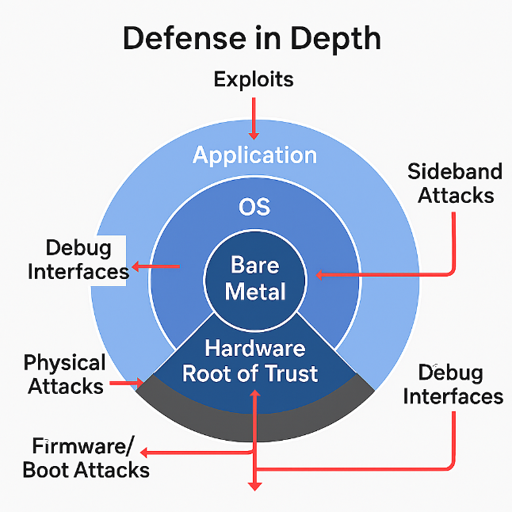 | 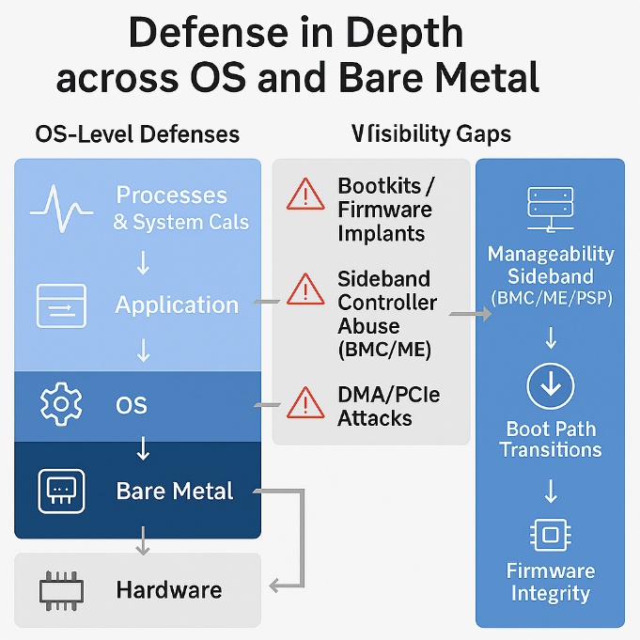

4. OS-Level AI vs. Bare-Metal AI — Why the Difference Matters
The Core Difference
OS-level AI sees what the OS can see. Bare-metal AI sees what attackers cannot hide—capturing lower-level, higher-fidelity signals that remain intact even when the OS is compromised.
This distinction defines the entire security value proposition.

4.1 Visibility Differences
OS-Level AI
Sees:
- Processes, threads
- System calls
- File and network activity
- User behavior
Blind to:
- Firmware tampering
- Boot-path manipulation
- DMA/PCIe attacks
- Microarchitectural anomalies
- Hypervisor escapes
- Rootkits that blind OS telemetry
- Sideband access and anomalies
If the OS is compromised, OS-level AI becomes blind.

Bare-Metal AI
Sees:
- Hardware invariants
- Boot ROM → firmware → bootloader transitions
- DMA/PCIe anomalies
- MMIO access patterns
- Power/thermal signatures
- Microarchitectural behavior
- Manageability interface access patterns
These signals cannot be suppressed or manipulated by an attacker.

OS-Level vs. Bare-Metal Visibility
Category | OS-Level AI Visibility | Bare-Metal AI Visibility | OS-Level Gaps | Bare-Metal Coverage
Processes & System Calls | Full visibility | Not applicable | Cannot detect below-OS activity | Covered by OS-level tools
File & Network Activity | Full visibility | Not applicable | Blind to firmware/network bypass | Covered by OS-level tools
Firmware Integrity | No visibility | Full visibility | Cannot detect firmware tampering | Detects unauthorized changes
Boot Path Transitions | No visibility | Full visibility | Cannot detect early-boot attacks | Detects boot-kits, root-kits
DMA/PCIe Activity | Limited or none | Full visibility | Blind to DMA/PCIe attacks | Detects DMA/PCIe anomalies
Microarchitectural Signals | No visibility | Full visibility | Cannot detect side-channels | Detects microarchitectural drift
Manageability Sideband (BMC/ME/PSP) | No visibility | Full visibility | Blind to out-of-band attacks | Detects malicious sideband access
Hypervisor Escapes | Limited | Full visibility | Cannot detect ring--1 activity | Detects anomalous transitions
Tamper Resistance | Low (software-based) | High (hardware-anchored) | Can be blinded by rootkits | Cannot be disabled by software

4.2 Threat Classes Each Layer Can Detect
OS-Level AI Detects (Post-Compromise)
- Malware
- Ransomware
- Suspicious processes
- Lateral movement
- User impersonation
- Application exploits
Bare-Metal AI Detects (Pre-Compromise)
- Firmware implants
- Boot-kits and root-kits
- Hardware trojans
- DMA attacks
- PCIe device spoofing
- Microarchitectural side channels
- Early-boot tampering
- Supply-chain implants
- Malicious sideband interface accesses

4.3 Evasion Resistance
OS-Level AI
Attackers can:
- Disable agents
- Patch kernel hooks
- Blind telemetry
- Run in ring-0 or ring--1
- Exploit early-boot gaps
Bare-Metal AI
Attackers cannot:
- Disable hardware telemetry
- Blind microarchitectural counters
- Fake boot transitions
- Hide DMA/PCIe anomalies
Bare-metal AI is inherently more resilient.

Attack Vectors vs. Detection Layers
Attack Vector | Targeted Layer | OS-Level Detection | Bare-Metal Detection
Exploits | Application / OS | ✅ Detectable post-compromise | ❌ Not primary focus
Rootkits | Firmware / Boot | ❌ Often invisible | ✅ Detectable via boot invariants
Firmware Implants | Firmware | ❌ No visibility | ✅ Full visibility
Sideband Attacks (BMC/ME) | Manageability Plane | ❌ Blind to out-of-band paths | ✅ Detects malicious access
DMA/PCIe Attacks | Hardware Interfaces | ❌ Blind to bus-level activity | ✅ Detects rogue behavior
Physical Attacks | Hardware / Debug Ports | ❌ No visibility | ✅ Detectable via tamper signals
Debug Interface Attacks | Bare Metal / Firmware | ❌ No visibility | ✅ Detects unauthorized access

4.4 Learning Model Differences
OS-Level AI
Learns from:
- Logs
- System calls
- User behavior
Limitations:
- High noise
- Easy to spoof
- Privacy concerns
Bare-Metal AI
Learns from:
- Hardware invariants
- Low-noise, deterministic signals
- Fleet-wide silicon behavior
Advantages:
- Hard to spoof
- Low data volume
- High anomaly fidelity

5. Value Proposition: Why Bare-Metal AI Is Needed Over Host (OS)-Based AI
5.1 Bare-Metal AI Protects the Platform, Not Just the Software
OS-Level AI Protects:
- Applications
- User space
- Kernel space
Bare-Metal AI Protects:
- Firmware
- Boot chain
- Hypervisor
- Hardware interfaces
- Silicon execution paths
- Manageability interface anomalies

5.2 Bare-Metal AI Cannot Be Blinded
OS-Level AI Can Be Disabled or Bypassed By:
- Kernel-level malware
- Rootkits
- Signed malicious drivers
- Boot-time tampering
Bare-Metal AI:
- Runs before the OS
- Anchors in hardware
- Cannot be disabled by software compromise

5.3 Bare-Metal AI Detects Attacks Earlier
OS-level AI detects attacks after the OS loads. Bare-metal AI detects attacks before the OS loads.

5.4 Bare-Metal AI Provides Higher-Quality Data
OS-Level Telemetry Is:
- Noisy
- High-variance
- Easy to spoof
Bare-Metal Telemetry Is:
- Deterministic
- Low-noise
- Hard to manipulate

5.5 Bare-Metal AI Enables Hardware-Rooted Mitigation
OS-Level AI Can:
- Kill processes
- Quarantine files
- Block network connections
Bare-Metal AI Can:
- Halt boot
- Enforce safe mode
- Isolate PCIe devices
- Block DMA
- Lock memory regions
- Prevent OS from loading if compromised

5.6 Bare-Metal AI Reduces Cost and Risk at Scale
Because it:
- Detects earlier
- Responds faster
- Contains threats at the hardware boundary
- Learns across the fleet
It directly reduces:
- Expected annual loss
- SLA penalties
- Downtime
- Incident response cost
- Regulatory exposure

6. Federated Learning at Bare Metal
Federated learning (FL) enables devices to collaboratively learn from local anomalies without sharing raw data.
Each device:
- Observes local behavior
- Detects anomalies using on-device models
- Computes local gradient updates
- Shares only aggregated updates
- Receives a global model incorporating fleet-wide learning
This architecture provides:
- Privacy-preserving fleet intelligence
- Distributed anomaly detection
- Cross-device immunity propagation
- Continuous adaptation to new threats

7. Quantifying the Security Benefit
7.1 Detection Metrics
- 20–50× faster MTTD
- ≥80% detection of novel attack patterns
- <Y% false negatives in red-team tests

7.2 Response Metrics
- 5–10× faster MTTR
- Fleet-wide mitigation propagation in hours

7.3 Time-At-Risk (TAR)
$$\text{TAR}=\text{MTTD}+\text{MTTR}$$
Up to 95% reduction in TAR for zero-day behaviors.

7.4 Blast Radius Reduction
- >90% reduction in affected devices

7.5 Expected Loss Reduction
$$\text{EL}=\sum_{i}{P(}{\text{Exploit}}_{i})⋅{\text{Impact}}_{i}$$
Bare-metal FL reduces:
- Probability of exploits
- Impact
- Time window of vulnerability

8. Architecture Overview
8.1 Components
- Bare-metal telemetry engine
- On-device anomaly detection model
- Federated learning client
- Secure aggregation server
- Policy/mitigation engine
- Attestation and trust scoring module

8.2 Data Flow
- Device collects hardware-level signals
- Local model detects anomalies
- Local gradients computed
- Encrypted updates sent to aggregator
- Global model updated
- Updated model deployed fleet-wide
- Mitigations applied automatically

9. Compliance and Regulatory Benefits
Federated learning at bare metal strengthens compliance posture for:
- NIS2 (EU)
- Cyber Resilience Act (CRA)
- ISO/SAE 21434 (Automotive)
- Industrial/OT security frameworks
- Telecom security requirements

10. Business Impact
10.1 Operational Benefits
- Fewer outages
- Lower SLA penalties
- Reduced incident response cost
- Faster recovery
- Lower support burden

10.2 Strategic Benefits
- Differentiated platform trust story
- Security that improves over time
- Reduced long-term risk exposure
- Stronger customer confidence
- Competitive advantage in regulated markets

10.3 Revenue Benefit
How Bare-Metal FL Drives Revenue
- Fewer outages → fewer lost transactions Every hour of downtime has a measurable revenue impact (e-commerce, SaaS, cloud services, manufacturing lines, etc.).
- Reduced breach probability → reduced financial loss Zero-day and firmware-level attacks are among the most expensive categories of cyber incidents.
- Lower incident response cost Faster detection and containment reduces IR labor, forensics, and recovery expenses.
- Higher platform reliability → higher customer retention Customers stay with platforms that demonstrate resilience and transparency.

Translate to a business metric
$$\text{Revenue Protected}=(\text{Downtime Avoided})×(\text{Revenue per Hour})$$
$$\text{Loss Avoided}=(\text{Reduced Probability of Breach})×(\text{Average Breach Cost})$$
10.4. Customer Confidence
How Bare-Metal FL Improves Trust
- Demonstrable hardware-rooted security Customers trust platforms that can prove tamper-resistant detection.
- Faster fleet-wide immunity Shows customers that the platform improves over time.
- Privacy-preserving analytics No raw data leaves the device — a major selling point for regulated industries.
- Transparent, measurable security posture Quantifiable metrics (MTTD, MTTR, TAR) build credibility.
Translate to a business metric
- Higher NPS (Net Promoter Score)
- Higher renewal rates
- Lower churn
- Increased win rate in competitive deals

10.5. Uptime & Resiliency
How Bare-Metal FL Improves Resiliency
- Detects attacks before OS loads → prevents outages
- Stops firmware-level persistence → prevents long-tail failures
- Fleet-wide learning → reduces blast radius
- Hardware-rooted mitigations → contain threats without downtime

Translate to a business metric
$$\text{Uptime Improvement}=\frac{\text{Incidents Avoided}}{\text{Total Incidents}}$$

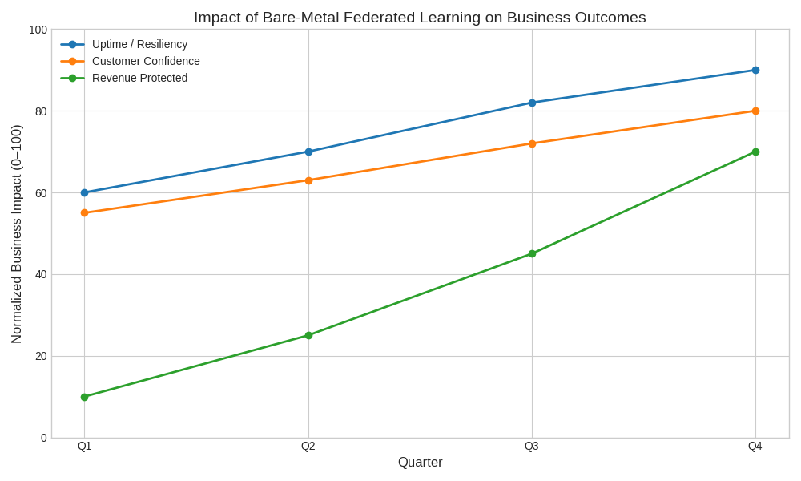
Graph - Example Value Story

11. Conclusion
Federated learning at bare metal provides a quantifiable, defensible, and future-proof approach to platform security. By reducing detection latency, response latency, time-at-risk, and blast radius — and by converting every new attack into fleet-wide immunity — this architecture transforms security from a static cost center into a compounding strategic asset.

This model directly addresses the hardest-to-quantify categories of security risk: zero-day vulnerabilities and evolving attacker techniques. It enables platforms to adapt in real time, learn continuously, and protect themselves autonomously.

Security becomes measurable. Risk becomes manageable. The fleet becomes smarter over time

